**BASE BUILDING  
ASSIGNMENT**  
**ASSIGNMENT QUESTION   
Q1:- What is the Grid ?**   
**ANS:-** *An intersection of vertical and horizontal lines is known as a grid.*

*● Major sections of a page are separated using CSS Grid layout.*

*● A grid-based layout system with rows and columns is provided by the grid*

*attribute. It eliminates the need for positioning and floating, making web page*

*creation simple.*

*● The grid layout enables us to construct grid structures represented in CSS rather*

*than HTML.*

*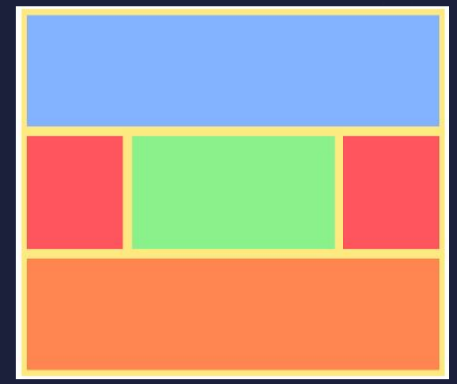● The user can align the pieces into rows and columns like a table. But using the CSS grid to construct a layout is simpler than using tables.*

Q2:-What is difference between Flex and Grid ?  **ANS:-   
 -: Grid and Flexbox :-***The basic difference between CSS grid layout and CSS flexbox layout is that flexbox was designed for layout in one dimension – either a row and a column . Grid was designed foe two-dimensional layout – rows and columns at the same time .*

Q3:- How can you define rows and columns for your Grid ?  
ANS:-We define rows and columns on our grid with the **grid-template-rows and grid-template-columns property.   
 -: Grid-templates-columns :-***The grid-template-columns property defines the number of columns in your grid*

*layout, and it can define the width of each column.*

*The value is a space-separated-list, where each value defines the width of the*

*respective column.*

*If you want your grid layout to contain 5 columns, specify the width of the 5*

*columns, or "auto" if all columns should have the same width.* **-: Grid-templates-rows :-***The grid-template-rows property defines the height of each row. It is used to define*

*the number of rows and their size in a grid container.*Q4:- List any two property of Grid-Items and Grid-Container ?  
**ANS:-   
 -: Two Property of Grid-Item :-  
Justify-self**

*The justify-self property is used to align a specific grid item along the horizontal (x)*

*axis within its grid cell.*

*● start – aligns the grid item to be flush with the start edge of the cell*

*● end – aligns the grid item to be flush with the end edge of the cell*

*● center – aligns the grid item in the center of the cell*

*● stretch – fills the whole width of the cell (this is the default)*

**Align-self**

*The align-self property is used to align a specific grid item along the vertical (y)*

*axis within its grid cell.*

*● start – aligns the grid item to be flush with the start edge of the cell*

*● end – aligns the grid item to be flush with the end edge of the cell*

*● center – aligns the grid item in the center of the cell*

*● stretch – fills the whole width of the cell (this is the default)  
.* **-: Two property of Grid-Container :-  
 -: Grid-templates-columns :-***The grid-template-columns property defines the number of columns in your grid*

*layout, and it can define the width of each column.*

*The value is a space-separated-list, where each value defines the width of the*

*respective column.*

*If you want your grid layout to contain 5 columns, specify the width of the 5*

*columns, or "auto" if all columns should have the same width.* **-: Grid-templates-rows :-***The grid-template-rows property defines the height of each row. It is used to define*

*the number of rows and their size in a grid container.*